**Name:DELNA ANNA JOY**

**Roll no:45**

**Batch : A**

**Date:19-03-2022**

**NETWORKING & SYSTEM ADMINISTRATION LAB**

**Experiment No.: 1**

**Aim**

Identify major components of computer system such as Motherboard ,RAM Module, Daughter cards, Bus slot, SMPS, Internal Storage Device, Interfacing ports

**Procedure**

**Motherboard**

The motherboard is a single platform to connect all of the components of a computer together. It connects the CPU, memory, challenging drives, optical drives, video card, sound card, and other ports and growth playing cards directly or via cables. It can be considered as the spine of a computer.

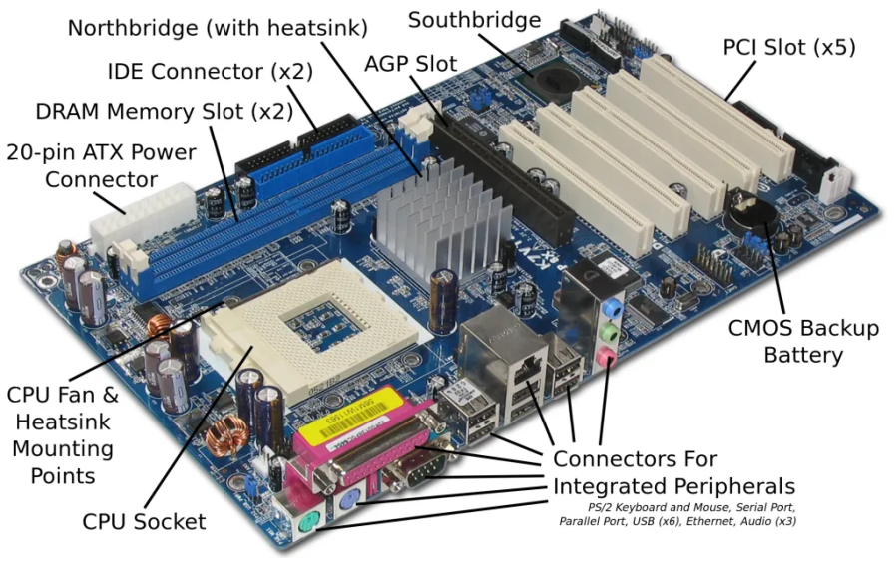

**RAM Modules**

* In computing, a memory module or RAM stick is a printed circuit board on which memory integrated circuits are mounted.Memory modules permit on hand set up and alternative in digital systems, in precise laptop buildings such as personal computers, workstations, and servers

. 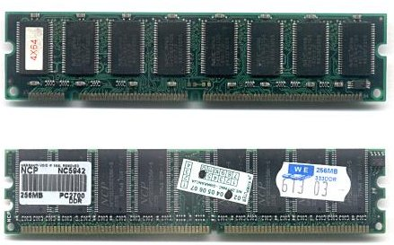

* The first reminiscence modules had been proprietary designs that had been special to a model of pc from a specific manufacturer. Later, reminiscence modules have been standardized through the use of the use of groups such as JEDEC and ought to be used in any computing device designed to use them.Types of memory module are:
* [TransFlash Memory Module](https://en.wikipedia.org/wiki/TransFlash_Memory_Module)
* [SIMM](https://en.wikipedia.org/wiki/SIMM), a single in-line memory module
* [DIMM](https://en.wikipedia.org/wiki/DIMM), dual in-line memory module
  + [Rambus](https://en.wikipedia.org/wiki/Rambus) memory modules are a subset of DIMMs, but are normally referred to as RIMMs
  + [SO-DIMM](https://en.wikipedia.org/wiki/SO-DIMM), small outline DIMM, a smaller version of the DIMM, used in laptops

**DaughterCard**

Daughtercard is a circuit board that plugs into and extends the circuitry of another circuit board. The other circuit board might also be the computer's essential board (its motherboard ) or it can also be some other board or card that is already in the computer, often a sound card. The time period is in many instances used with the aid of producers of wavetable daughtercard that connect to present sound cards.

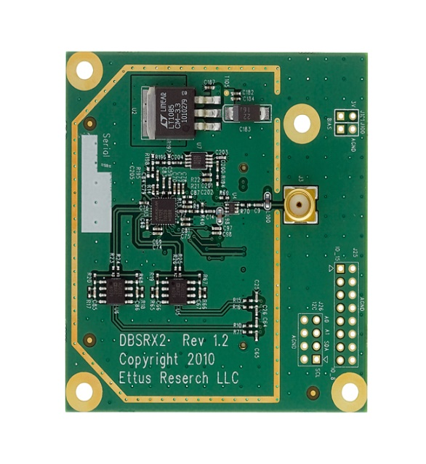

**Bus Slot**

**Bus slot** is also known as  **expansion port**, an **expansion slot** is a connection or port inside a [computer](https://www.computerhope.com/jargon/c/computer.htm) on the [motherboard](https://www.computerhope.com/jargon/m/mothboar.htm) or [riser card](https://www.computerhope.com/jargon/r/risecard.htm). It provides an installation point for a hardware expansion card to be connected. For example, if you wanted to install a new video card in the computer, you'd purchase a video expansion card and install that card into the compatible expansion slot.

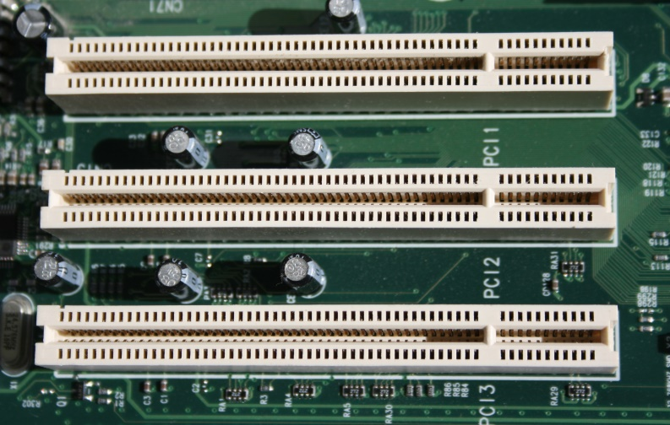

**SMPS**

A switched-mode power supply (SMPS) is an electronic circuit that converts power using switching devices that are turned on and off at high frequencies, and storage components such as inductors or capacitors to supply power when the switching device is in its non-conduction state.

Switching power supplies have high efficiency and are widely used in a variety of electronic equipment, including computers and other sensitive equipment requiring stable and efficient power supply.

A switched-mode power supply is also known as a switch-mode power supply or switching-mode power supply.

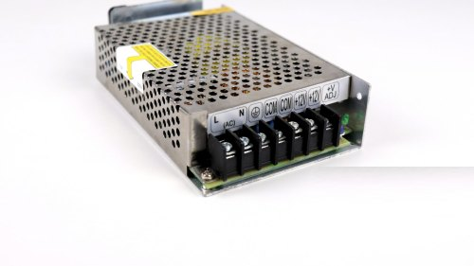.

**Internal Storage Devices**

Some storage devices are classed as 'internal' which means they are inside the computer case.

Most computers have some form of internal storage. The most common type of internal storage is the hard disk.

At the most basic level, internal storage is needed to hold the operating system so that the computer is able to access the input and output devices.

It will also be used to store the applications software that you use and more than likely, the original copies of your data files.

Internal storage allows the data and applications to be loaded very rapidly into memory, ready for use. The data can be accessed much faster than data which is stored on an external storage device. This is because internal storage devices are connected directly to the motherboard and its data bus whereas external devices are connected through a hardware interface such as USB, which means they are considerably slower to access.

**Interfacing Ports**

A computer is a device that transforms data into meaningful information. It processes the input according to the set of instructions provided to it by the user and gives the desired output. As we know that we can connect multiple external devices with the computer system. Now, these devices are connected with the computer using Ports. The ports are the physical docking points present in the computer through which the external devices are connected using cables. Or in other words, a port is an interface between the motherboard and an external device of the computer. There are different types of ports available:

* Serial port
* Parallel port
* USB port
* PS/2 port
* VGA port
* Modem port
* FireWire Port
* Sockets
* Infrared Port
* Game Port
* Digital Video Interface(DVI) Port
* Ethernet Port